**Group name:** Team Physíque

**Date:** January 18, 2016

**Research question:** Does gender identity impact bacteria on cell phone screens?

**Control condition:** Cell phones belonging to female identifying students.

**Experimental condition:** Cell phones belonging to male identifying students.

**Synopsis of investigation:**

Do people identifying as male carry more bacteria on their iPhones than people identifying as female? That’s the question we hope to answer over the course of this experiment. By swabbing a specific section of 12 different peoples’ iPhones (around the home button), we hope to prove that people who identify as male have more bacteria on their iPhone screen than people who do not identify as male.

A recently conducted study yielded results that support our hypothesis; 68.5% of males do not wash their hands after using the restroom, whereas only 37.2% of females don’t [1]. This lack of hygiene from males leads our research team to believe that their hands may not be the only dirty thing on them; the sterility of their iPhones most likely suffers as well.

If our hypothesis is correct in that males do carry more bacteria on their iPhone screen, appropriate improvements could be made upon society. With the new information, schools and other educational facilities and mediums could propel hygiene movements into action that are targeted more toward males and their habits. Seeing as 66% of American doctors are male, the information that our study brings to light could potentially save lives in terms of cleanliness in operating rooms and emergency situations.

Our experiment tests two genders; not biological sex. Our results are reflective of societally-induced habits of the two tested gender identities rather than biological differences between sexes, and we do not plan on gathering or reporting data aggregated by sex, but instead by gender identity. This is because we want to focus on societally-induced habits, specifically hygiene habits, and differences that may appear between those with different genders, rather than potential biological bacteria differences between sexes.

**Bacterial count hypothesis:** Cell phones that belong to a person who identifies as a male will have more bacterial colonies than cell phones belonging to those who identify as a woman.

**Motility hypothesis:** Bacteria from the cell phones that belong to a person who identifies as male will be more motile than bacteria from the cellphones of those who identifies as a woman.

**Gram Stain hypothesis:** Bacteria from the cell phones that belong to a person who identifies as male will be more gram negative than bacteria from the cellphones of those who identifies as a woman.

**Antibiotic resistance hypothesis:**

**Ampicillin sensitivity:** Bacteria from cell phones that belong to a person who identifies as male will be more ampicillin sensitive than bacteria from the cell phones belonging to those who identify as a woman.

**Kanamycin sensitivity:** Bacteria from the cell phones that belong to a person who identifies as male will be more kanamycin sensitive than bacteria from the cell phones belonging to those who identify as a woman.

**Gentamicin sensitivity:** Bacteria from the cell phones that belong to a person who identifies as male will be more gentamicin sensitive than bacteria from the cell phones belonging to those who identify as a woman.

**Rationale**: A previously conducted study found that 68.5% of men do not wash their hands after using the bathroom while only 37.2% of women do not wash their hands [1]. Simple measures such as increased hand hygiene can be used reduce the bacteria on and therefore potential contaminations caused by cell phones [2], suggesting that decreased hygiene among the male gender would lead to the presence of a greater number of bacteria with less antibiotic resistance [3] on their personal cell phones. 1 in 6 cell phones have also been found to be contaminated with faecal matter [3] such as E. coli [4], likely from a lack of hand hygiene after using the bathroom, suggesting that this ratio may be higher among males than females. E. coli bacteria use flagellum to move [5], suggesting a relatively high motility, and also have a negative gram stain [6].

**Impact:** Cell phones, which are commonly used in hospitals for communication, can be vehicles for transmitting pathogens to patients [7]. Therefore those with health care professions need to be consistently reminded of this danger and taught to regularly disinfect their phones, which can reduce bacterial load by close to 90% [8]. In the United States, males make up 66% of all doctors while females make up only 34% [9], so finding a significant gender difference in cell phone bacteria could be helpful in understanding how to best conduct education on this subject. A better understanding of the relationship between bacteria and personal cell phone usage could also aid in the development of antibacterial cases and screen protectors for cell phones [10], and understanding how this technology could be marketed to different genders could assist in its popularization.

**Materials:**

* Cotton swabs
* Agar plates
* Petri Dishes
* Gloves
* Goggles
* Ampicillin
* Kanamycin
* Gentamicin
* Cell phones (preferably all iPhones)

Sampling Procedure:

1. Each of Dr. Driscoll’s students (that possess an iPhone) are assigned a number that corresponds to their phone. Students label their iPhones with their respective numbers using a small (roughly .5 in X .5in in diameter) strip of tape and a Sharpie marker, writing directly on the tape and adhering the tape to the back of their phone. Only iPhones will be used to account for potential differences between phone screens and materials with other types of phones (such as Androids).
2. Students place iPhones inside individual small-sized ziplock bags. Once bagged, students place iPhones into two separate gender-corresponding bags. The two gender sorted bags of iphones are then collected by lab supervisor. If less than 10 iPhones of each gender are obtained (20 total), this process will be repeated using students from another Citizen Science class until the sample size has been fulfilled.
3. Each group will be randomly and blindly assigned two iPhones, not knowing the ownership or corresponding gender of their iPhones, and prepare the iPhone for swabbing. Random and blind assignment of the assignment of phones serves to help control for human error, bias, and other confounding variables.
4. Each group will prepare to sample by placing gloves on hands and by placing a sterile sheet of plastic down over their workspace. Once workspaces are ready and deemed sanitary by lab supervisor, each group will be distributed two iPhones. Each group will place randomly select an iPhone to begin swabbing.
5. Students remove randomly-selected iPhone from ziploc bag, placing it face-up on their workspace.
6. Using a ruler, each group will measure their iPhone’s length and width, careful not to contaminate the face (screen) of the phone by making contact with ruler. Students will then accordingly divide the surface area of the iPhone’s faces into 6 symmetrical regions as shown in diagram 1. Each group will then visually approximate the centerpoint of each region of the phone’s surface.
7. Groups then collect a 4cm2 sample at each of the 6 approximated counterpoints. Using gloves and a fresh swab for each, students transfer samples individually to a region of an agar plate, making sure that each sample is labeled on the agar plate with the region that it was taken from and the number of the phone.
8. Groups repeat steps 5-7 using the remaining iPhone.
9. Samples will then be left overnight to grow, making sure that that temperature of air, humidity remain constant and representative of indoor room-temperature environment.
10. Each student corresponding to a phone in the study will complete a survey detailing their information about their living environment, phone use, and sanitary/hygienic practices. This information will be helpful in isolating gender as a variable and identifying any confounding variables. Since this is a categorical study and not a quantitative one, there will be no control variable.
11. Students will return the following day and test each sample taken for bacteria count.
12. After analyzing bacteria count data, lab coordinator will select cultures for further isolation(motility, gram stain, and resistance). Cultures corresponding to the surface region showing the mean average bacteria count (disregarding outliers) will be selected for further isolation.
13. Each group will then be randomly assigned a male or female phone to test for gram staining and antibiotic resistance. Someone outside of the testing will then assign the control group either a 1 or a 2, and the experimental group the other number. They will then plac~~e~~ 5 strips of paper with an 1 written on them and 5 strips of paper with a 2 written on them in a hat, and having each group grab 1 piece of paper from the hat to determine whether they use their control sample or their experimental sample. No one else in the experiment will know which gender each number represents until after testing is complete, to account for potential bias.

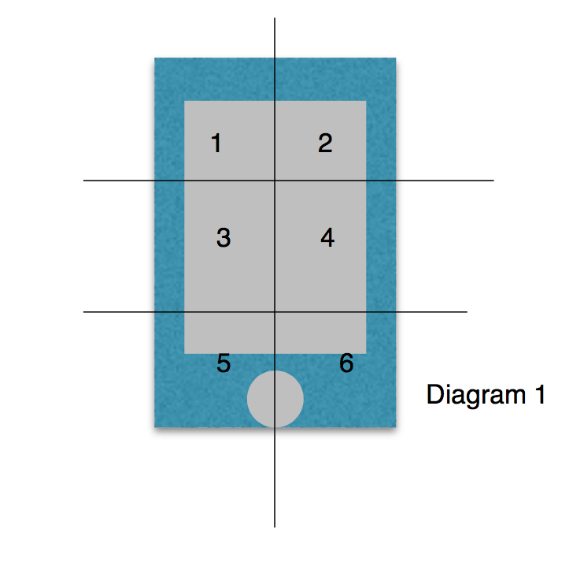

References

[1] Anderson, J. L., Warren, C. A., Perez, E., Louis, R. I., Phillips, S., Wheeler, J., . . .

Misra, R. (2008). Gender and ethnic differences in hand hygiene practices

among college students. *American Journal of Infection Control*, *36*(5), 361-368.

http://dx.doi.org/10.1016/j.ajic.2007.09.007

[2] Brady, R. R., Fraser, S. F., Dunlop, M. G., Paterson-Brown, S., & Gibb, A. P. (2007).

Bacterial contamination of mobile communication devices in the operative

environment. *Journal of Hospital Infection*, *66*(4), 397-398.

http://dx.doi.org/10.1016/j.jhin.2007.04.015

[3] Antibacterial soap? You can skip it -- use plain soap and water. (2016, September 2).

Retrieved January 18, 2017, from FDA website:

http://www.fda.gov/ForConsumers/ConsumerUpdates/ucm378393.htm

[4] Contamination of UK mobile phones and hands revealed. (2011, October 14).

Retrieved January 11, 2017, from LSHTM website:

http://www.lshtm.ac.uk/newsevents/news/2011/mobilephones.html

[5] Faecal bacteria. (n.d.). Retrieved January 11, 2017, from Lenntech website:

http://www.lenntech.com/faecal-bacteria.htm

[6] Swiecicki, J.-M., Sliusarenko, O., & Weibel, D. B. (2013). From swimming to

swarming: Escherichia coli cell motility in two-dimensions†. *Integr Biol (Camb)*,

1490-1494. Retrieved from

https://www.ncbi.nlm.nih.gov/pmc/articles/PMC4222179/

[7] Xu, G. (1997, October 31). *Gram-negative bacteria* [Fact sheet]. Retrieved January

11, 2017, from UPHS website:

http://www.uphs.upenn.edu/bugdrug/antibiotic_manual/gram4.htm

[8] Zakai, S., Mashat, A., Abumohssin, A., Samarkandi, A., Almaghrabi, B., Barradah,

H., & Jiman-Fatani, A. (2016). Bacterial contamination of cell phones of medical

students at King Abdulaziz University, Jeddah, Saudi Arabia. *Journal of*

*Microscopy and Ultrastructure*, *4*(3), 143-146.

http://dx.doi.org/10.1016/j.jmau.2015.12.004

[9] Singh, S., Acharya, S., Bhat, M., Rao, S. K., & Pentapati, K. C. (2010). Mobile phone

hygiene: potential risks posed by use in the clinics of an Indian dental school.

*Journal Of Dental Education*, *74*, 1153-1158. Retrieved from MEDLINE database.

[10] Distribution of physicians by gender [Newsgroup post]. (2016, September).

Retrieved from

http://kff.org/other/state-indicator/physicians-by-gender/?dataView=1¤tTimeframe

=0

[11] Page, K., Correia, A., Wilson, M., Allan, E., & Parkin, I. P. (2015). Light-activated

antibacterial screen protectors for mobile telephones and tablet computers.

*Journal of Photochemistry and Photobiology A: Chemistry*, *296*, 19-24.

http://dx.doi.org/10.1016/j.jphotochem.2014.08.011